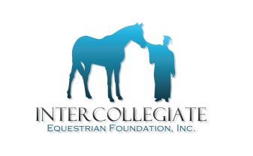
2017 IEF SCHOLARSHIP NOTED AWARD WINNERS

Joan Johnson Memorial Award
Aimee Schulz
Iowa State University
Zone 7 Region 4

Emily Hilscher Memorial Award
Emily Chafins
Liberty University
Zone 4 Region 4

Jack Fritz Memorial Award
Katie Groomes
Penn State University
Zone 3 Region 1

Zone 7 Scholarship Award
Jordyn Wendt
West Texas A&M University
Zone 7 Region 2

Jon Conyers Memorial Award
Leslie Giorgetti
Hollins University

Bob Anthony Memorial Award
Haley Ruffer
Alfred University

2017 LISTING OF IEF SCHOLARSHIP WINNERS
ZONE REGION FIRST/LAST NAME COLLEGE/UNIVERSITY
1 | 3 | Rebecca | Chun | Amherst College
1 | 3 | Sabrina | Fox | Mount Holyoke College
1 | 3 | Bridget | Finnerty | Mount Holyoke College
1 | 5 | Samantha | Doyle | University of Connecticut
2 | 2 | Lucy | Pronk | The University of Guelph
5 | 2 | Chloey | Guy | Judson College
5 | 2 | Jayla | Land | Georgia State University
6 | 2 | Kelly | O’Bryan | Miami University
6 | 2 | Corinne | Conaway | The Ohio State University
6 | 2 | Mariah | Sherer | The Ohio State University
7 | 2 | Kyla Cheyenne | Hook | Oklahoma Panhandle State University
7 | 2 | Morgan | Robledo | West Texas A&M University
7 | 2 | Daniella | Salaverria | West Texas A&M University
7 | 5 | Tess | Cummings | Truman State University
7 | 5 | Allison | Gossett | Black Hawk College
7 | 5 | Kinsey Leigh | Ayres | Black Hawk College
8 | 4 | Natalie | Nahirney | University of British Columbia

